Nem Negash

09/11/2021

CMSC 426

Lab 1

Domain name information

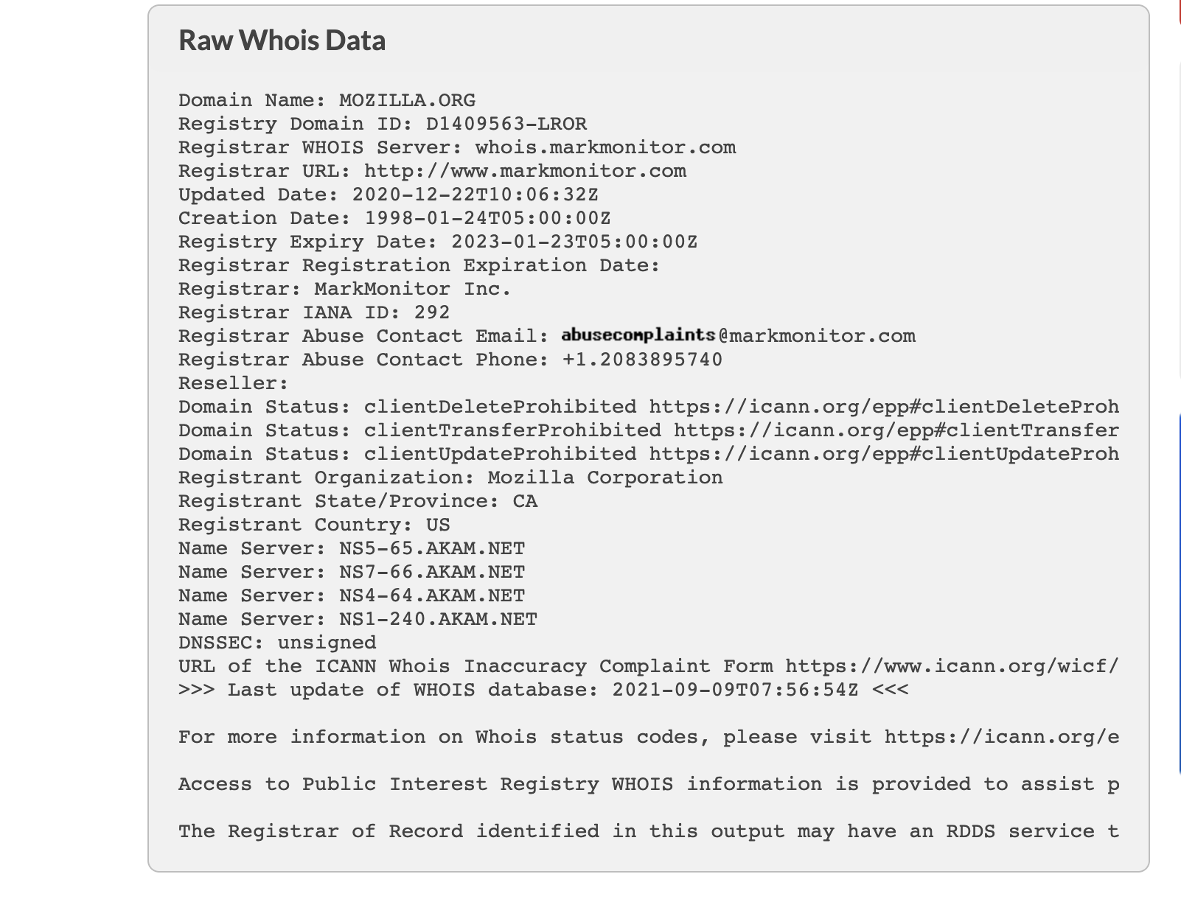

Finding IP Address

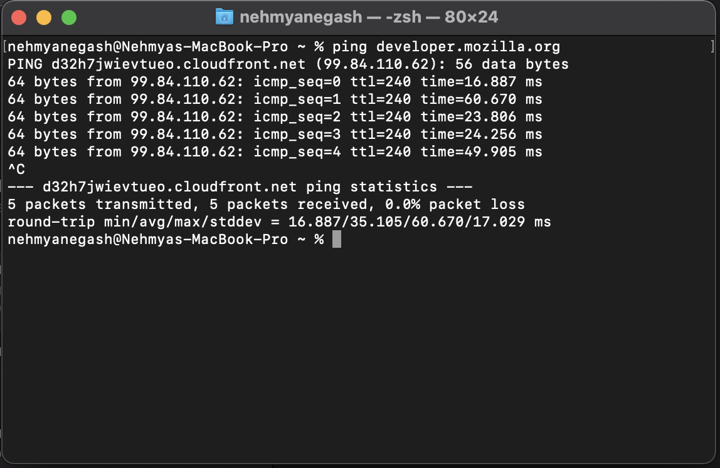

Accepts Ping requests.

Main IP Address: 99.84.110.62

Finding the Host company

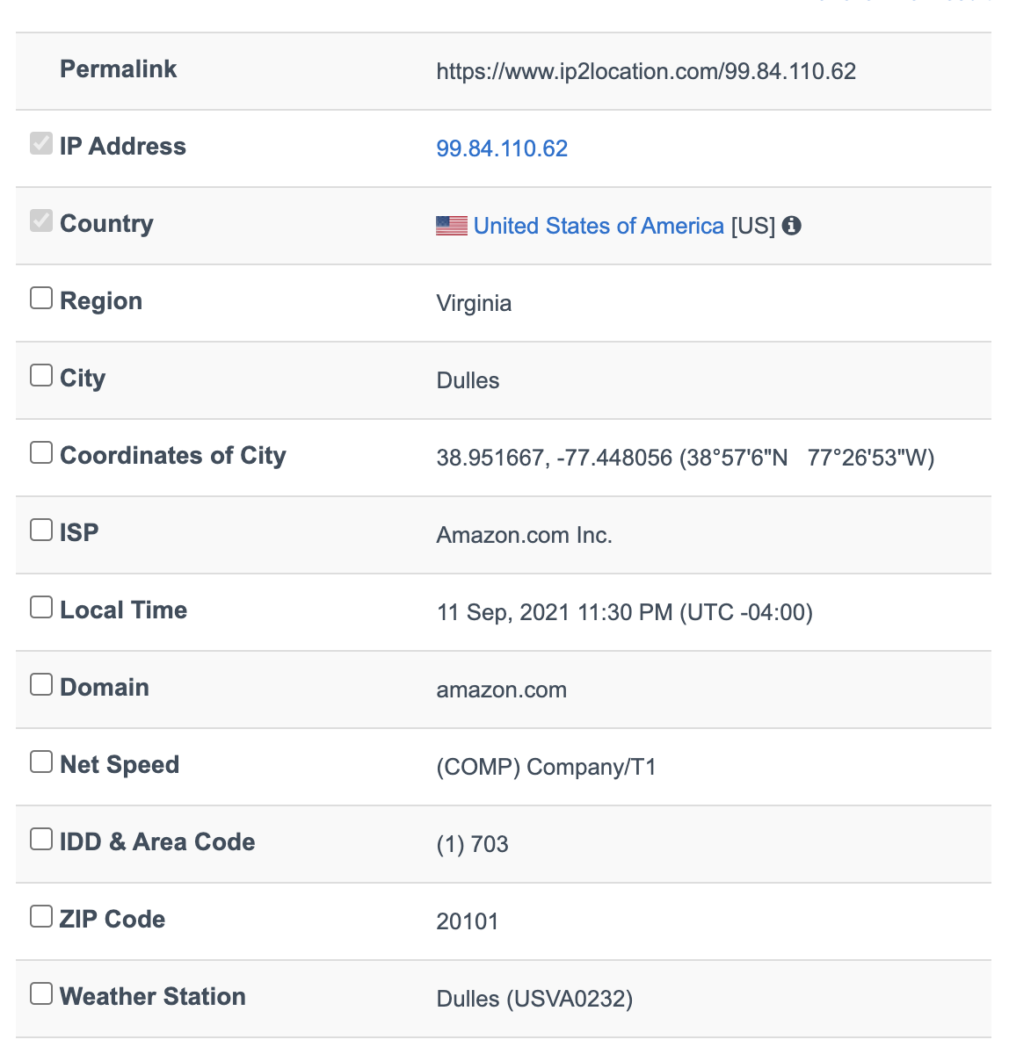

IP Address Ranges

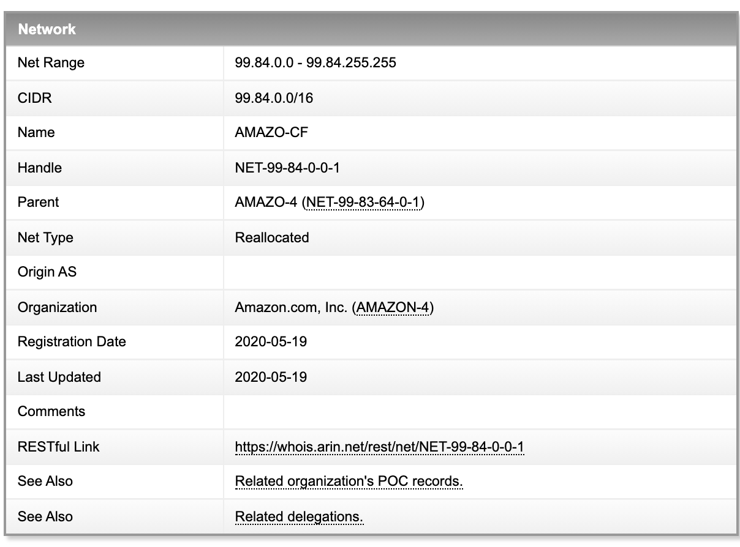

History of the Website

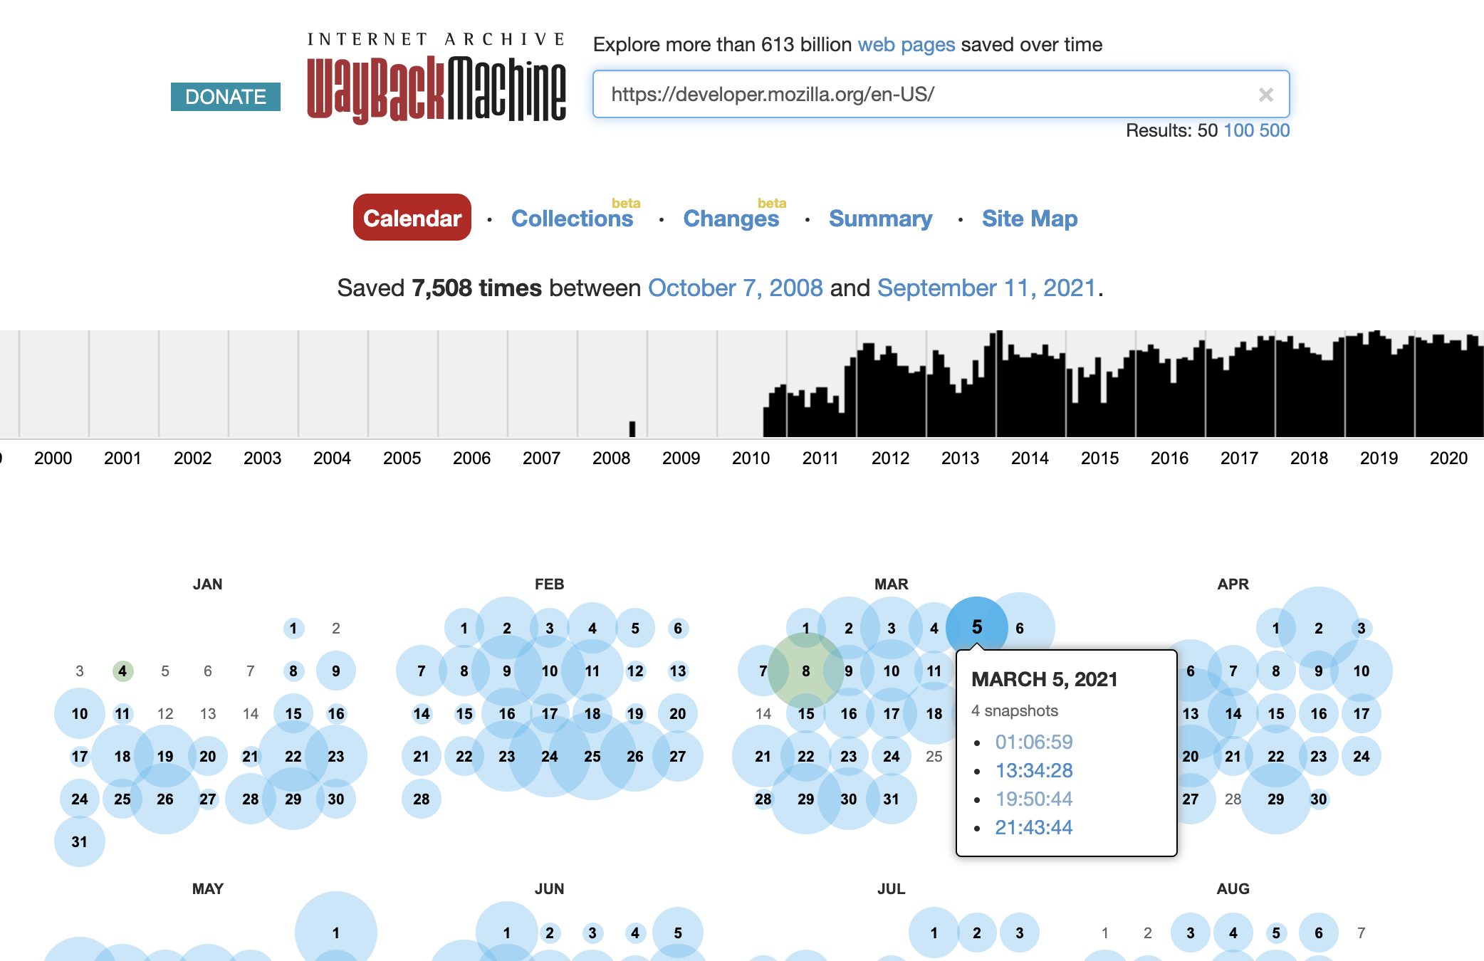

OSINT Collection

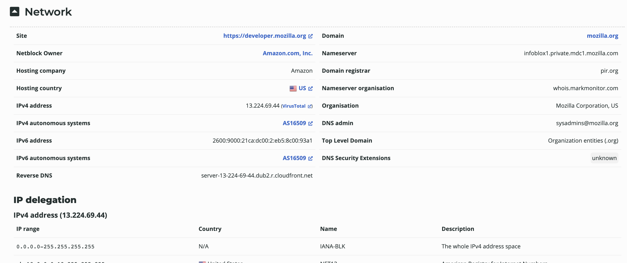

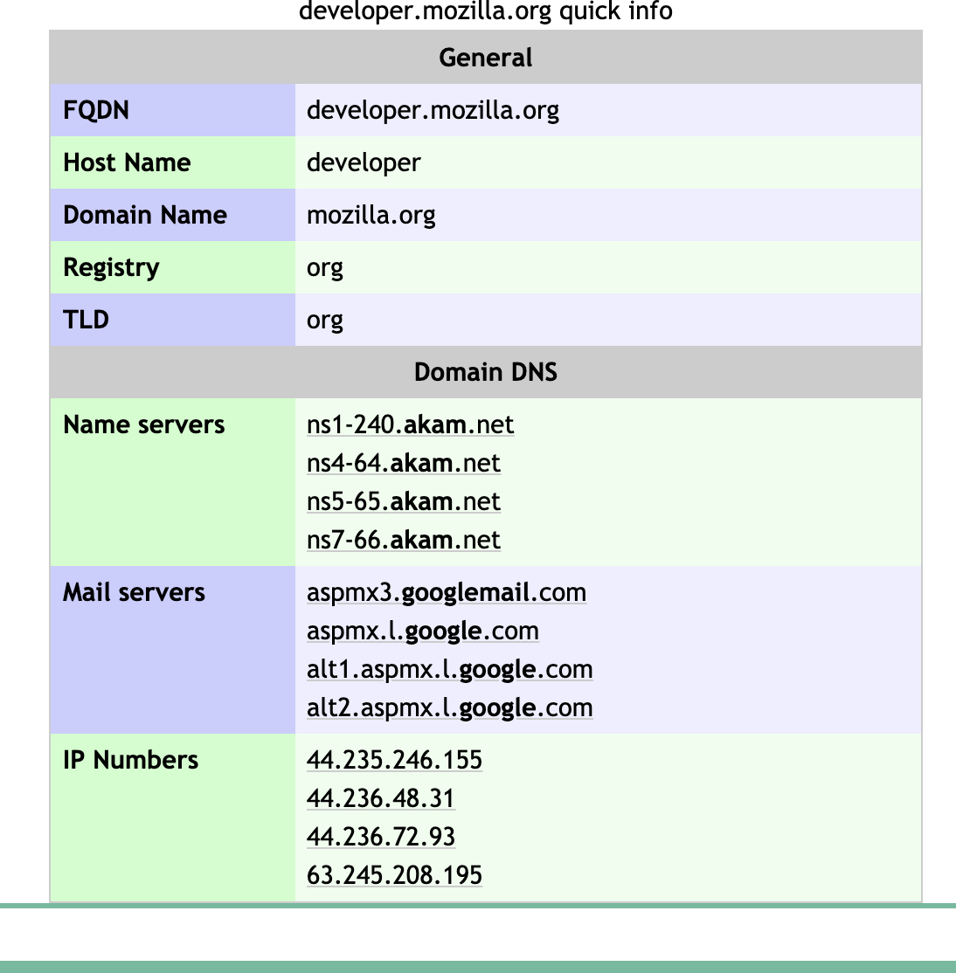

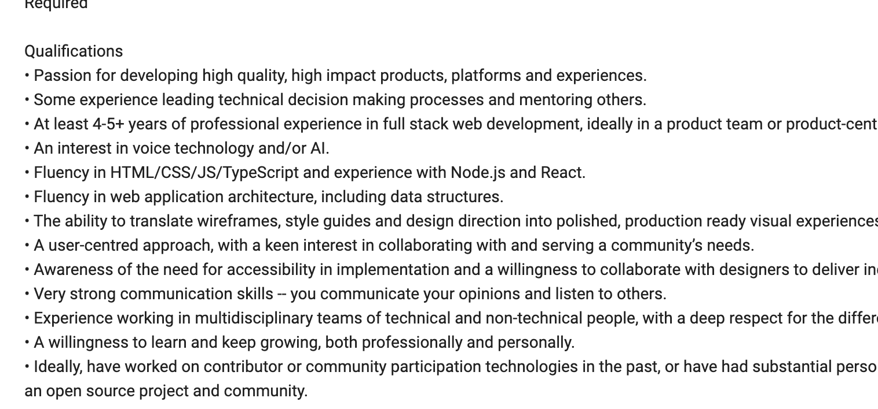

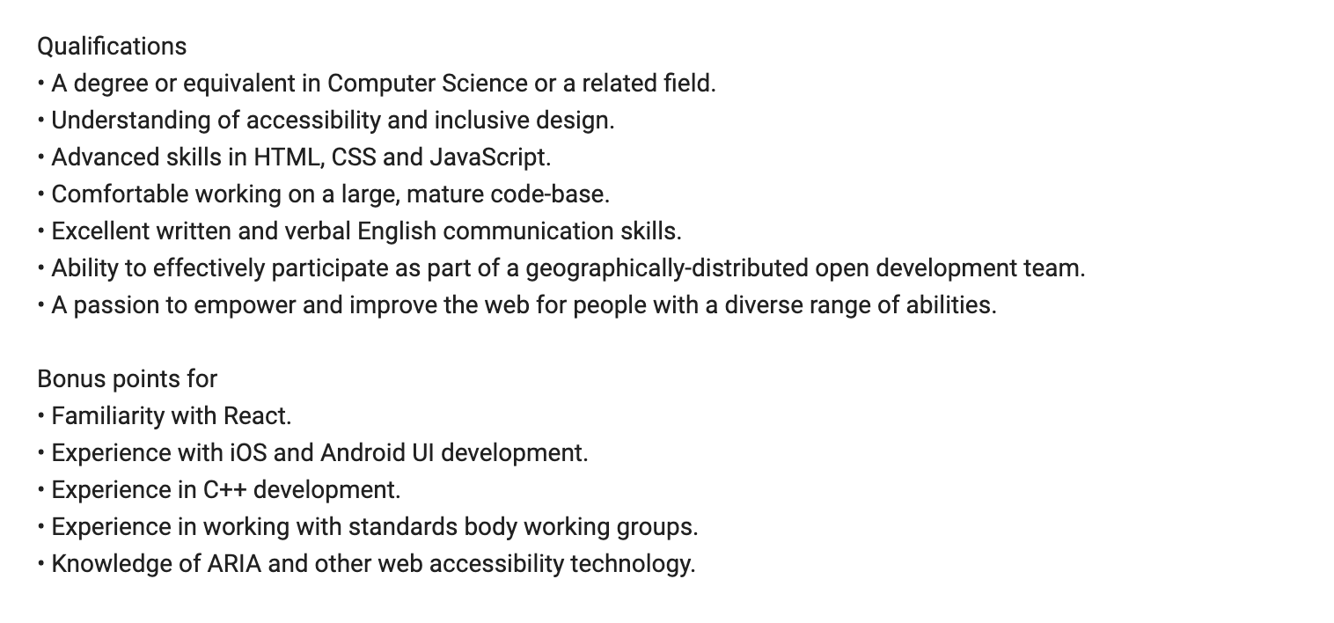

OSINT Research with Shodan

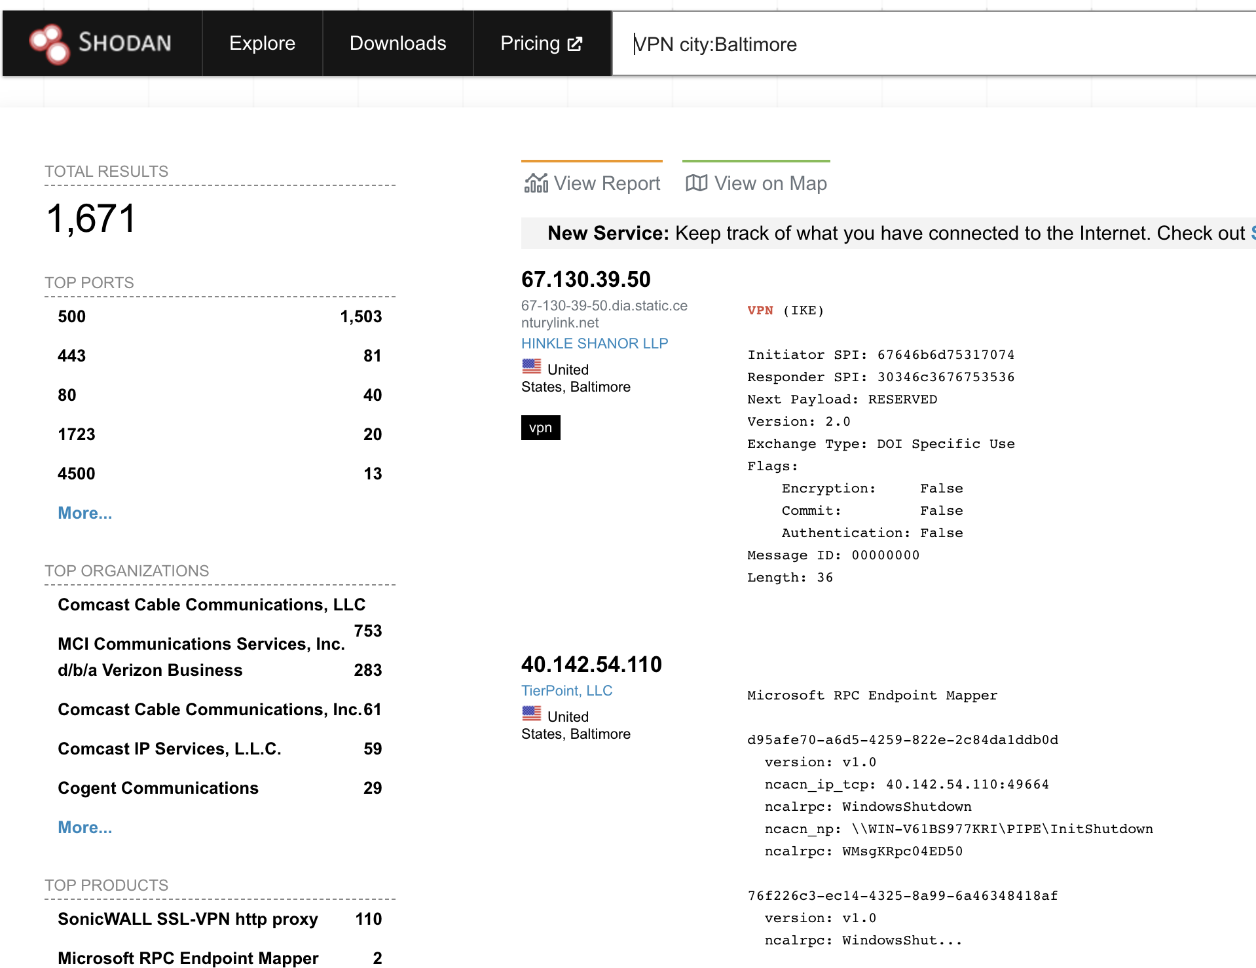

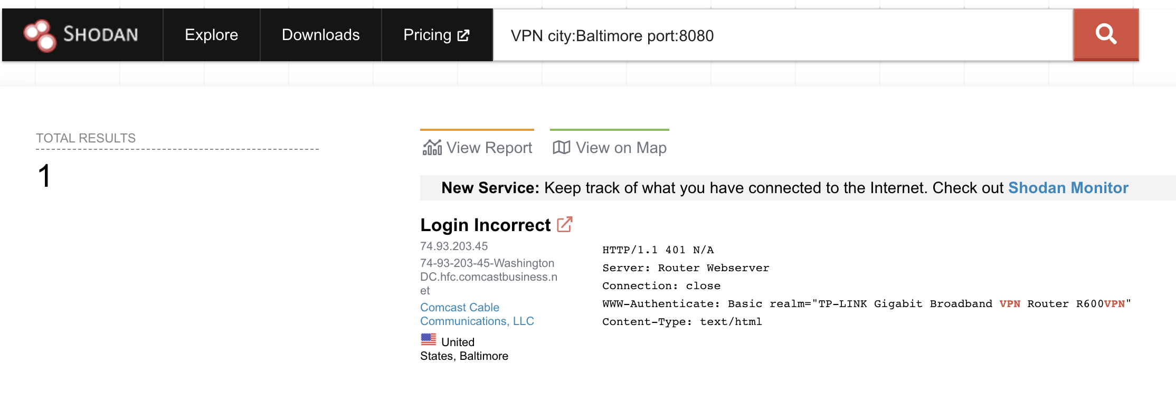

**OSINT Research with Kali**

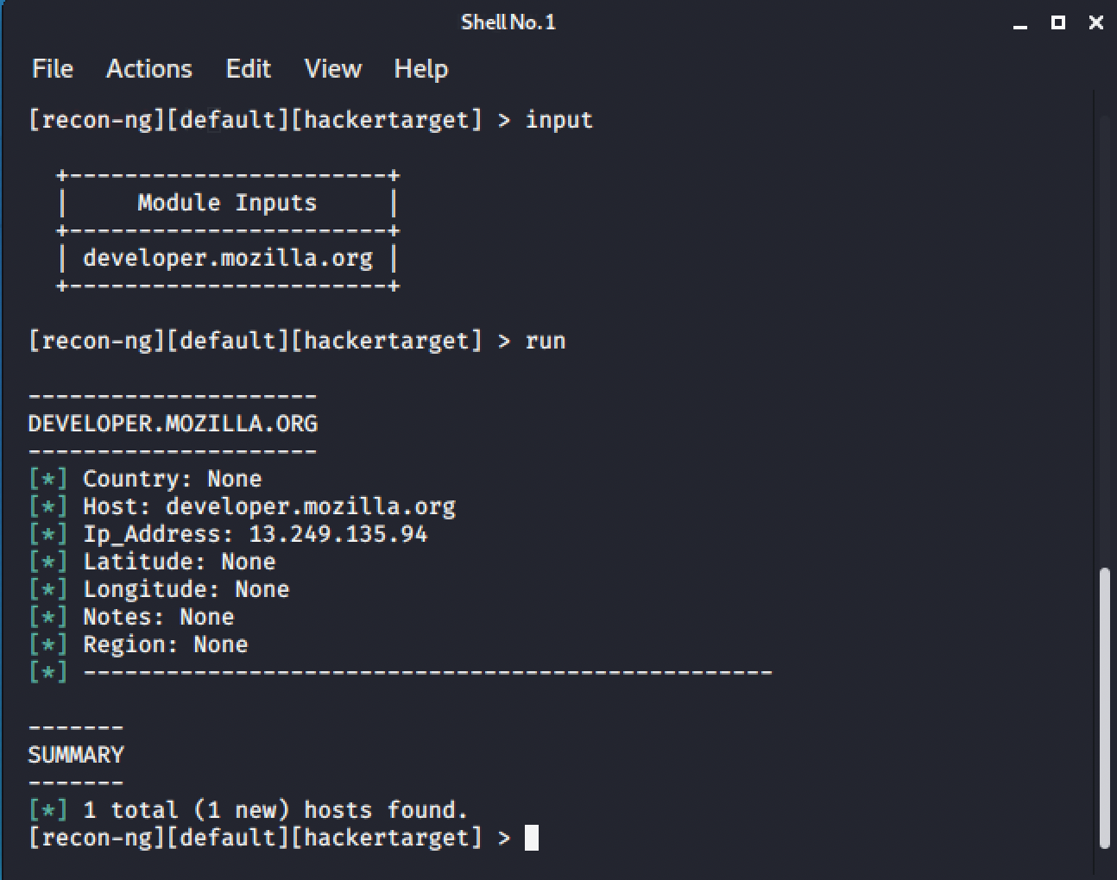

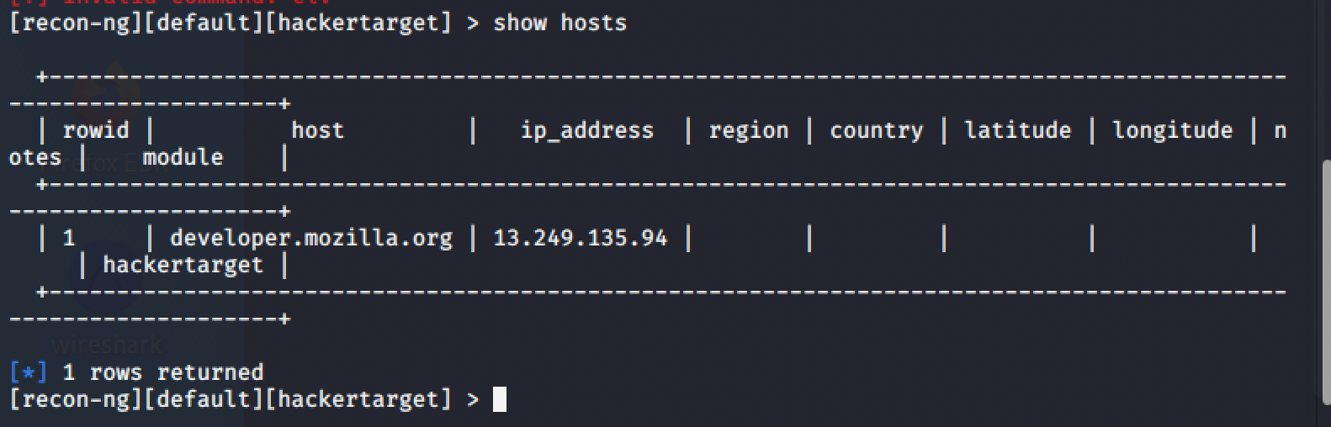

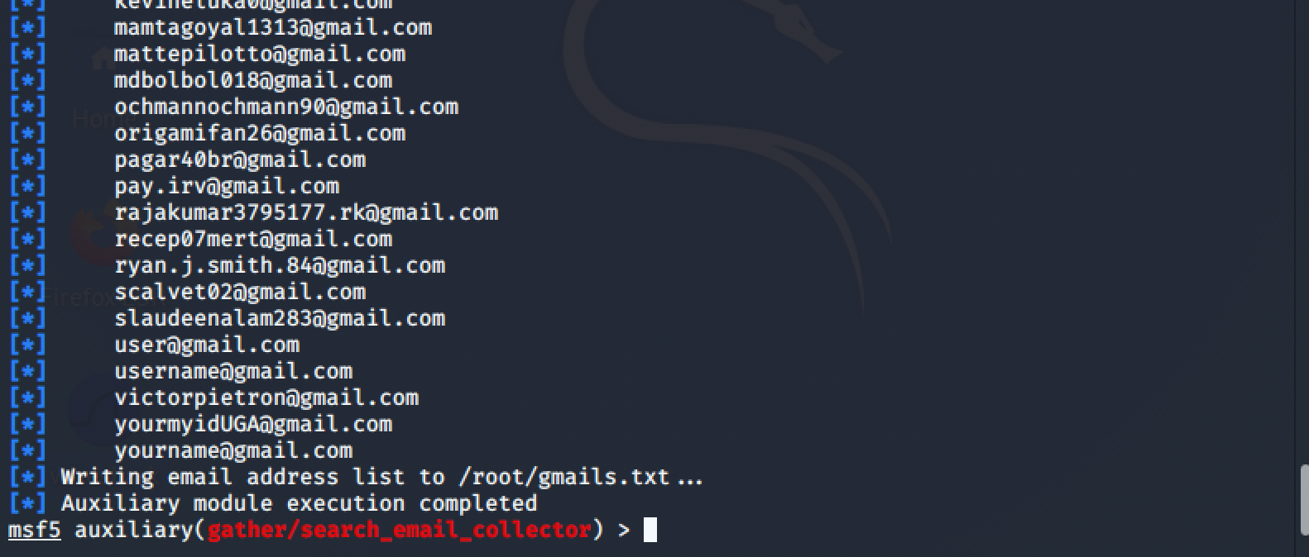

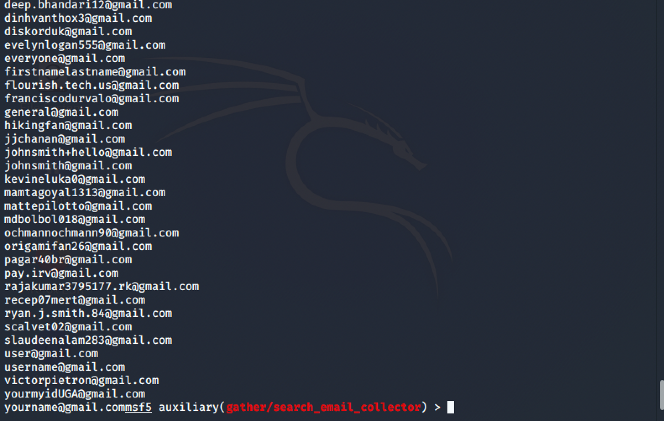

Repeated with **umbc.edu** domain:

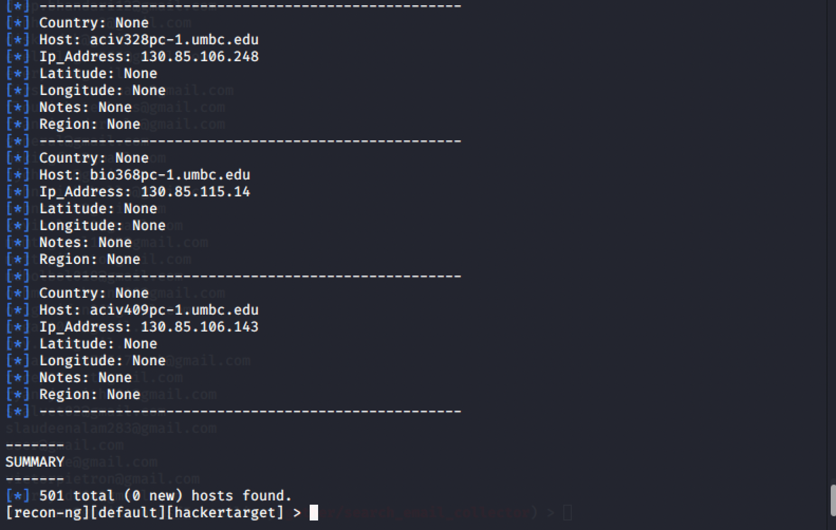

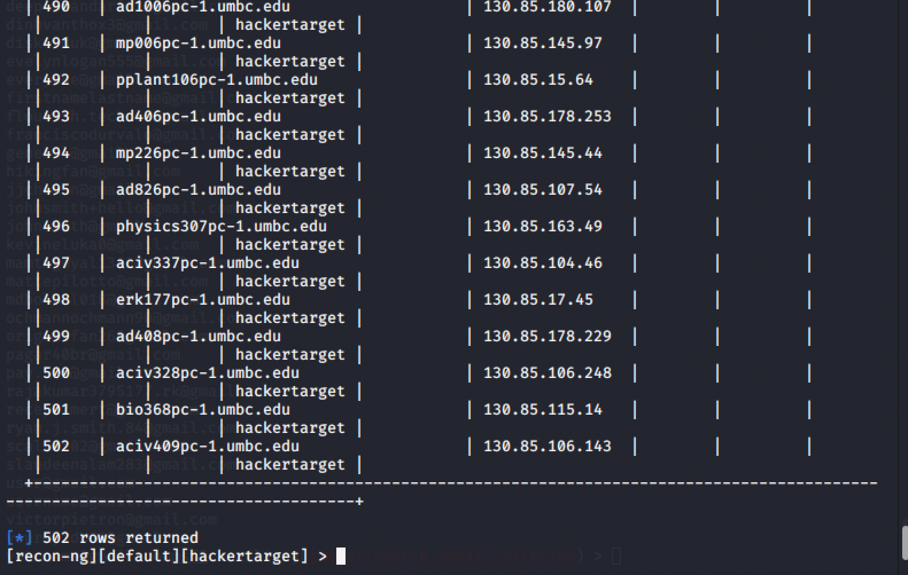

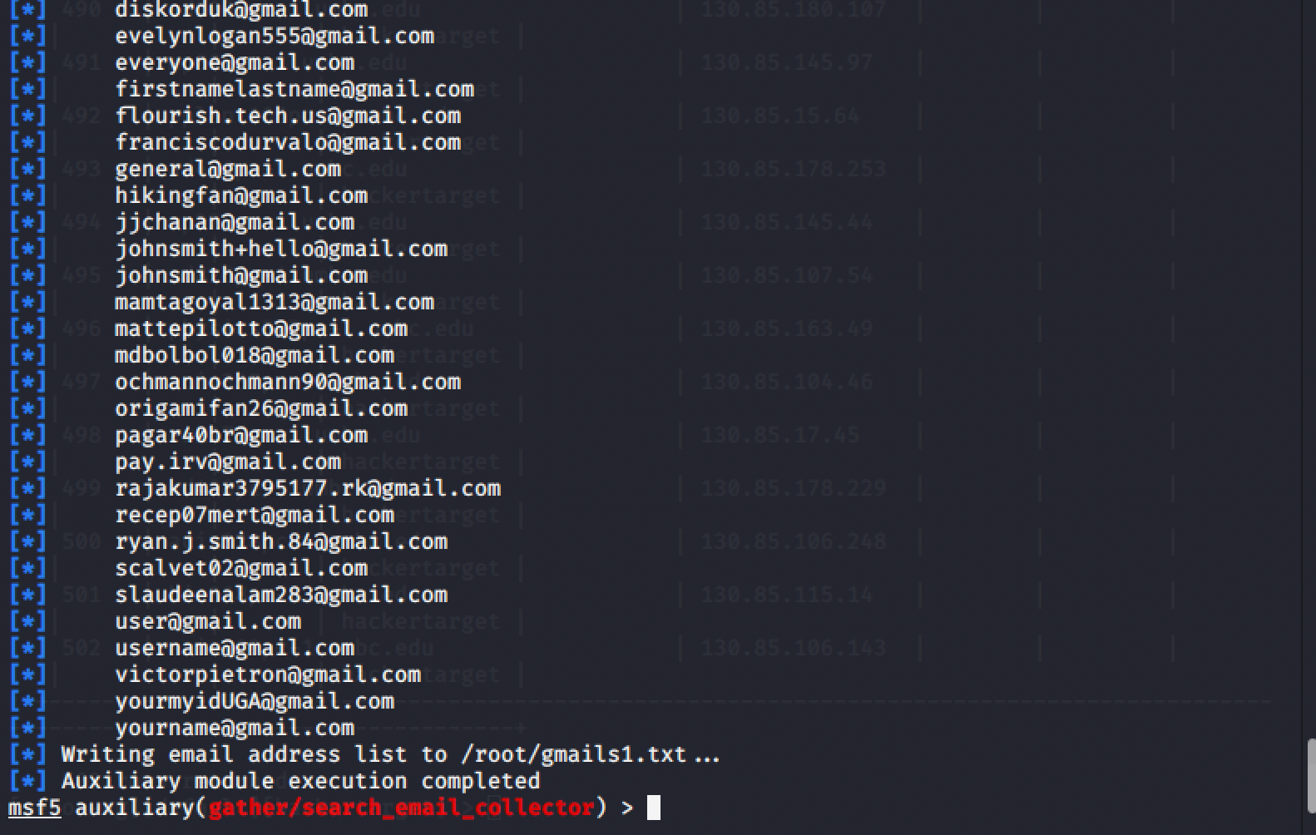

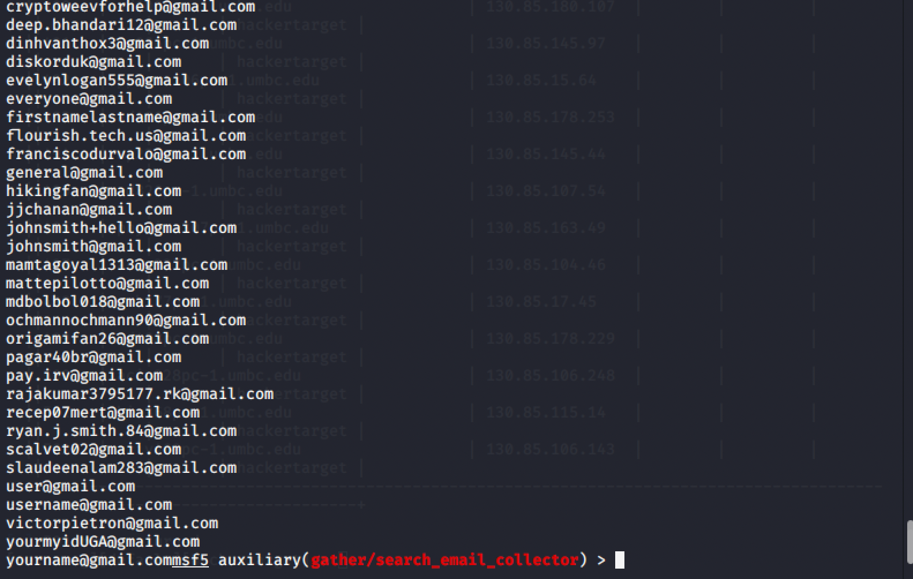

Conclusion and Lab Report:

1. Which of the tools/techniques used in this lab would you personally find most useful in gaining information about potential targets as a penetration tester?
   1. I think the best tool is the Metasploit Framework. Once you have gathered the company’s domain names, you can use this tool to find emails that are associated with accounts that can be used to log into the system. From there you can use the other tools to find the password that belongs to the email.
   2. Another tool is IP2location which helps find the host company of the domain for the company. For example, for the developer.mozilla.org domain, the host company is Amazon and Amazon host their clients webpages using AWS CloudFront which is a service that is provided by Amazon. This can help an attacker figure out what kind of backend system it is trying to penetrate and figure out the vulnerabilities of the service.
2. Did these exercises make you think of other capabilities that you would find helpful for gaining OSINT on targeted systems?
   1. Another capability that I was able to find was that hackers can plant devices that track information on which is going in and out of a network by planting these devices at the physical location of the company office. Using the information hackers can find out more information about the company network and how information is being encrypted and sent in and out of the network. This gets the hacker a step closer to intercepting and decrypting information that is being received or sent out in the network.
3. Now that you have become an expert in Open-Source Intelligence collection, use your Internet stalking skills to find as many companies and university teaching positions as you can where the instructor has been employed? Also, can you find any sordid details about yourself lurking out there on the Internet?
   1. Information on David Freet:
      1. <https://www.linkedin.com/in/dfreet>
         1. This lists all past and current employment locations
   2. Information on Nem Negash:
      1. <https://www.linkedin.com/in/nehmya-negash-1187b818b>
         1. Employment history
      2. <https://wildelakerobotics.weebly.com/alumni.html>
         1. High school information
      3. <https://www.cyberbackgroundchecks.com/address/44-halfpenny-ln/catonsville/md>
         1. My address, age, and family members(this is a bit scary)
      4. <https://www.facebook.com/nehmiya.woldegebreyel>
         1. Facebook and other social media accounts that are associated with facebook